SDITDI Malaysia Sdn Bhd
Lot 2.51, 2nd Floor, Kompleks Desa Kepong, KUALA LUMPUR 52100 MY
sditdimsia@gmail.com

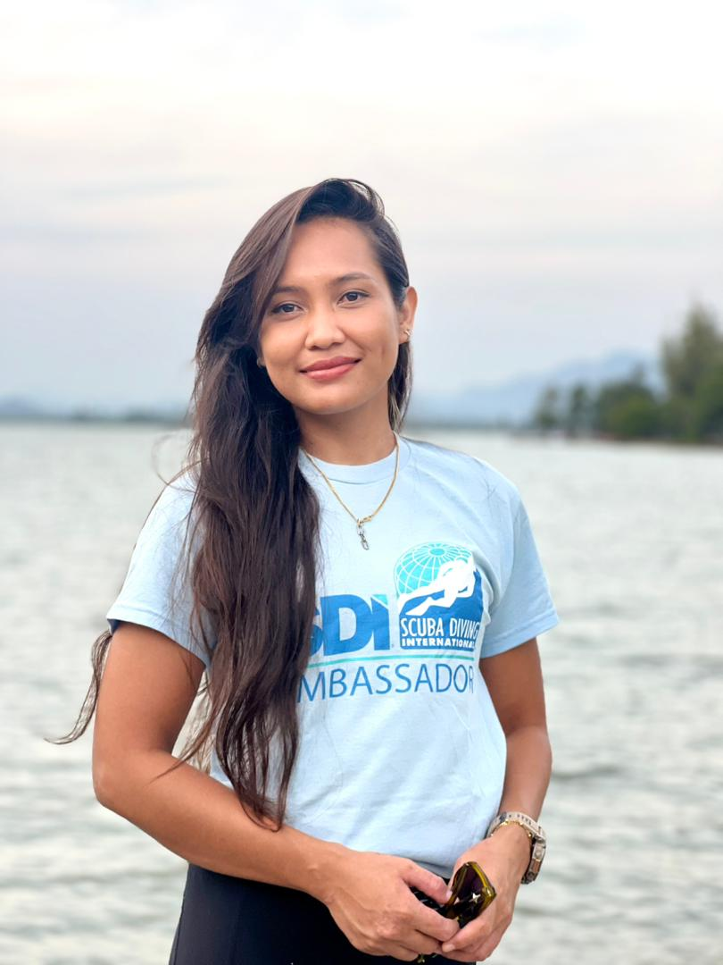

Instructor Personal Data



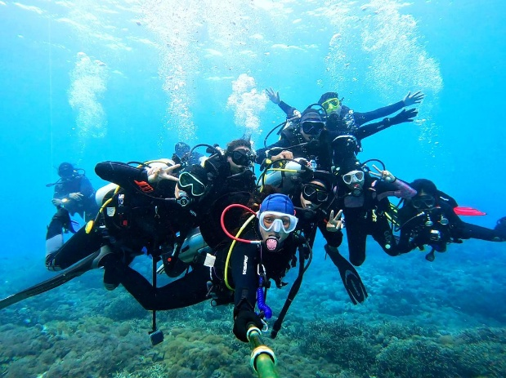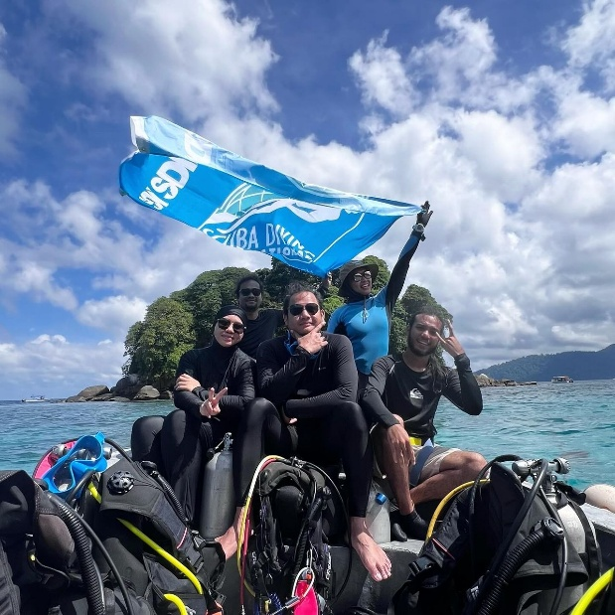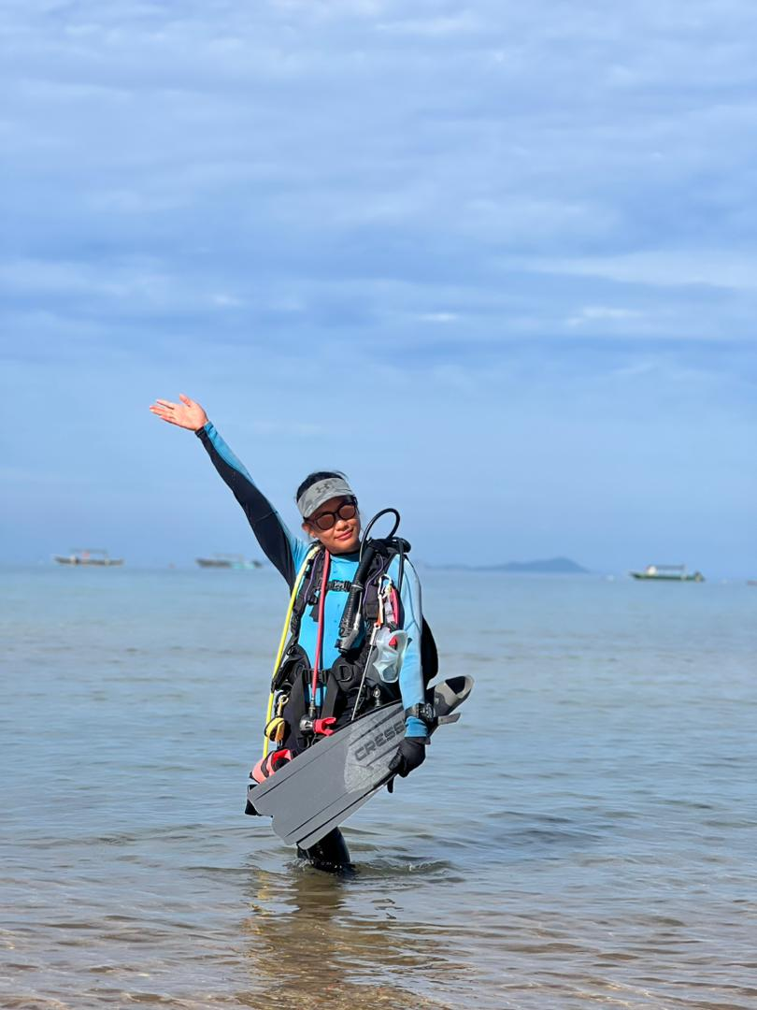

- Personal Data
SITI NURSARAH BINTI SALEHHODIN

Name
16337
Instructor No. #
diving.scubanorth@gmail.com
E-mail address
0174173387
Mobile Phone No.
Kuala Lumpur, Malaysia
Home Base
Tioman Island
Island Base

- Credentials
Please list down your Diver / Instructor Qualifications & Experiences

Ambassador Scuba Diving International
Open Water Scuba Diver Instructor
Wreck Instructor
Underwater Navigation Diving Instructor
Night-Limited Visibility Diving Instructor
Marine EcoSystems Awareness Instructor
Deep Diving Instructor
Dive Experience Leader
Bloodborne Pathogens Instructor
Oxygen Administration Instructor
Adult and Child Emergency Instructor
Social Media Name & Link (Facebook, Instagram, Youtube, Website etc.)
Instagram : SitiNurSara https://www.instagram.com/sitinursara?igsh=MTljN2xzZ3doYW84eQ==
Tiktok : bySitiNurSara https://www.tiktok.com/@bysitinursara?_r=1&_t=ZS-926ZRAg4eSV
Facebook :Siti NurSara https://www.facebook.com/share/1BZnL5knxn/?mibextid=wwXIfr
YouTube: sitinursara711 https://youtube.com/@sitinursara711?si=7RpYib6DCQSPLjHn

